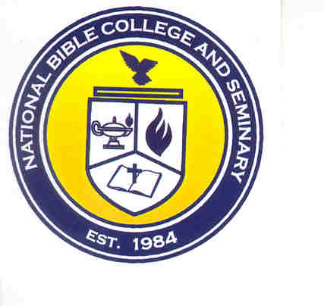
National Bible College and Seminary

6700 Bock Road, Fort Washington, MD 20744

Phone: 301-567-9503; Fax: 301-861-5371
Fall 2016 Classroom Assignments
*Subject to change without notice*
8/22/2016 – 12//10/16

Monday

Course Title | Instructor | Room | Meeting Time
OTS102: Old Testament Survey II | Rev. Malisa Vickerie | 235 | 6:30pm – 9:30pm
Tuesday
Course Title | Instructor | Room | Meeting Time
THE 504:Advanced Apologetics | Dr. Melvin Hall | 235 | 6:00pm – 9:00pm
Wednesday |  |  |  | Dr. Melvin Hall | 235 | 6:30pm – 9:30pm
Course Title | Instructor | Room | Meeting Time
PTH301: Leadership Principles | Dr. Sharon Evans Eldridge | 232 | 6:00pm – 9:00pm
HIS301: American History & Government | Dr. Jerry Jones | 235 | 6:30pm – 9:30pm
Thursday

Course Title | Instructor | Room | Meeting Time
THE509: Christian Theology | Dr. Melvin Hall | 232 | 6:00pm – 9:00pm
OTS101: Old Testament Survey I | Dr. Jerry Jones | 235 | 6:30pm – 9:30pm
Friday

Course Title | Instructor | Room | Meeting Time
THE262: Comparative Religions | Rev. Malisa Vickerie | 235 | 6:30pm – 9:30pm
Saturday
Course Title | Instructor | Room | Meeting Time
CNS130: Basic Christian Counseling | Dr. Sharon Evans Eldridge | 235 | 12:00pm – 3:00pm
ONLINE

Course Title | Instructor | Day | Meeting Time
THE512: Old Testament Theology II | Dr. Clara Guyton | Tuesday | Synchronous  6:00pm – 9:00pm
THE513: Christian Theology II | Dr. Clara Guyton | Thursday | Synchronous  6:00pm – 9:00pm
Revised: 8/4/2016

