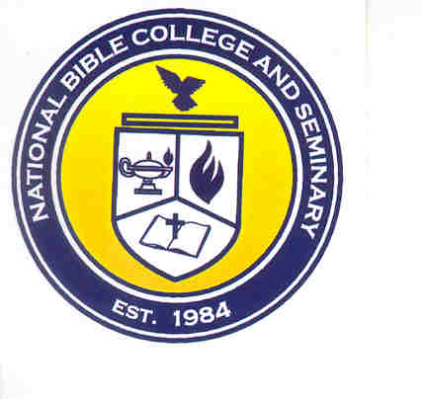
National Bible College & Seminary
6700 Bock Road
Fort Washington, MD 20744
Phone: 301-567-9503; Fax: 301-839-7520

Faculty File Checklist

⁭ Ecclesiastical Resume

⁭ Adjunct Faculty Application Form

⁭ Certifications (if applicable)

⁭ Certificates (if applicable)

⁭ Awards (if applicable)

⁭ Picture (if possible 2x2)

⁭ Transcripts or Degrees (Official Copy)

