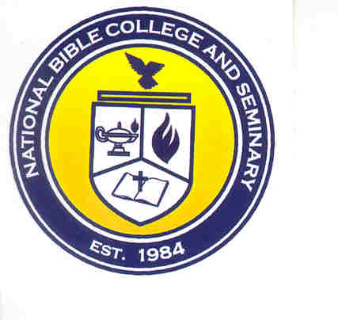
National Bible College and Seminary

6700 Bock Road; Fort Washington, Maryland 20744

Phone: 301-567-9500; Fax: 301-839-7520

MEMORANDUM

TO: NBC&S Faculty & Students

FROM: JaNice Parks, Registrar

DATE: December 5, 2007

RE: Inclement Weather

As the season of inclement weather is upon us, below are the policies for closing the college and seminary:

- We generally follow what the area colleges and universities decide. We do not follow Prince George’s County decisions.

- We will publicize any closings via NBC 4. Please check their website (www.nbc4.com) or their news broadcast.

- Decisions regarding closure are made by 7:30 a.m. for morning classes and after 3:00 p.m. for evening classes. Please do not call the office before these times.

- You may also sign up with nbc4.com to have an alert sent to you via email when the school is closed. Follow the instructions below to sign-up.

- Go to www.nbc4.com

- Click on NBC4 Connected on the left side of the screen. (You may have to scroll down.)

- Click on Sign Up for School Closings

- Scroll down (if necessary) to Closings and Delays E-mail Sign-Up

- Enter your e-mail address.

- Select the first letter of your institution’s name – “N”

- Click the “Next” button.

- Select Your School or Institution from the drop down menu: National Bible College

- Optional: Send it to My Text Pager/Phone

- Click “Next Step” button.

- Enter pager /cell phone address, not the number (optional). Your email address should automatically appear in the box.

- Check each box corresponding to the box regarding where to notify you.

- Click the “Submit Your Changes” button.

- You should get a message that you have been registered.

- If you receive an error message, there is a mistake in your email address or your cell phone / pager address. Click the Back button and make any necessary corrections.

