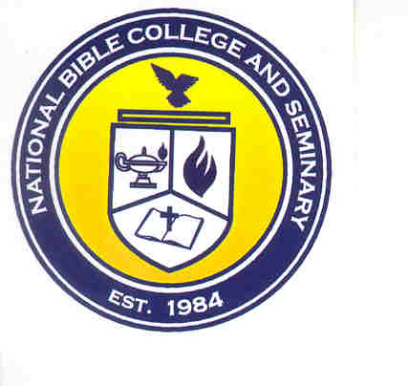
National Bible College and Seminary

6700 Bock Road; Fort Washington, Maryland 20744

Phone: 301-567-9500; Fax: 301-839-7520

MEMORANDUM

TO: NBC&S Faculty and Students

FROM: Dr. Aaron Jones, Executive Vice President

DATE: July 30, 2026

RE: NBC&S New Location
Greetings in the name of our Lord and Savior Jesus Christ. I pray that each one of you had a blessed Christmas season; and may this year be prosperous. NBCS is excited about another semester and to see how God is going to continue to impart wisdom and knowledge for the building of His Kingdom.

The National Christian Academy is need of major renovations; until this is complete, they have moved into the World Education Center along with the Finance Office. This will only affect about 10% of our students, most students attend at night. NBC&S is now located on the second floor (elevator to UL) of the World Education Center. Below are the new room assignments:

Staff | Position | Level | Room
Dr. Aaron Jones | Executive Vice President | UL | 236
Dr. Femi Falana | Academic Dean | UL | 239
Dr. Ralph Sutherland | Dir. Of Institutional Effectiveness | UL | 239
JaNice Parks | Registrar | UL | 238
Crystal Fletcher | Administrative Assistant | UL | 237
Finance Office | Make Payments | LL | 150
Library | Check out books | LL | 103
Resource Center | Computer Lab | UL | 202
Classrooms | Undergraduate/Graduate | UL | 230-235

Thank you in advance for your support and cooperation in this new move.

