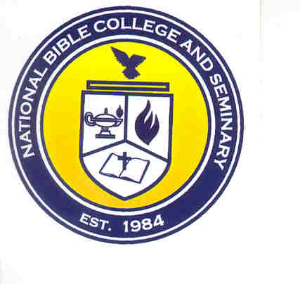
National Bible College and Seminary

6700 Bock Road; Fort Washington, Maryland 20744

Phone: 301-567-9500; Fax: 301-839-7520

MEMORANDUM

TO: NBC&S Students

FROM: JaNice Parks, Registrar

DATE: July 30, 2026

RE: NBC&S Library

We now have a Librarian Assistant to help students in the library. Ms. Anna Jones will be in the library on Tuesdays and Thursdays from 9:00 AM – 5:00 PM. Students will be able to checkout books during these times. The hours will expand as the school acquires additional staff.

Reference materials may not be used off campus. Reference materials should be used in the library. If the need arises to use them in another area of the school, students must submit their Student ID and complete the Sign-Out Sheet for Reference Materials.

Students are not to remove any books, magazines, or other resource material from the library without properly checking out.

If students would like to volunteer in the library, please download an application from the school website (www.nationalbiblecollege.org) and submit it to the Office for consideration.

